**Assignment No**: 06

**Aim**: Implement Union, Intersection, Complement and Difference operations on fuzzy sets. Also cre- ate fuzzy relation by Cartesian product of any two fuzzy sets and perform max-min composition on any two fuzzy relations.

# Objectives:

1. To learn different fuzzy operation on fuzzy set.
2. To learn min-max composition on fuzzy set.

# Software Requirements:

Ubuntu 18.04

# Hardware Requirements:

Pentium IV system with latest configuration

# Theory:

Fuzzy logic is a superset of conventional (Boolean) logic that has been extended to handle the con- cept of partial truth- truth values between "completely true" and "completely false". As its name sug- gests, it is the logic underlying modes of reasoning which are approximate rather than exact. The im- portance of fuzzy logic derives from the fact that most modes of human reasoning and especially common sense reasoning are approximate in nature.

The essential characteristics of fuzzy logic as founded by Zader Lotfi are as follows.

* In fuzzy logic, exact reasoning is viewed as a limiting case of approximate reasoning.
* In fuzzy logic everything is a matter of degree.
* Any logical system can be fuzzified
* In fuzzy logic, knowledge is interpreted as a collection of elastic or, equivalently , fuzzy constraint on a collection of variables
* Inference is viewed as a process of propagation of elastic constraints.

The third statement hence, defines Boolean logic as a subset of Fuzzy logic.

# Fuzzy Sets

Fuzzy Set Theory was formalised by Professor Lofti Zadeh at the University of California in 1965. What Zadeh proposed is very much a paradigm shift that first gained acceptance in the Far East and its successful application has ensured its adoption around the world. A paradigm is a set of rules and regulations which defines boundaries and tells us what to do to be successful in solving problems

within these boundaries. For example the use of transistors instead of vacuum tubes is a paradigm shift - likewise the development of Fuzzy Set Theory from conventional bivalent set theory is a paradigm shift. Bivalent Set Theory can be somewhat limiting if we wish to describe a 'humanistic'

problem mathematically. For example, Fig 1 below illustrates bivalent sets to characterize the temperature of a room.

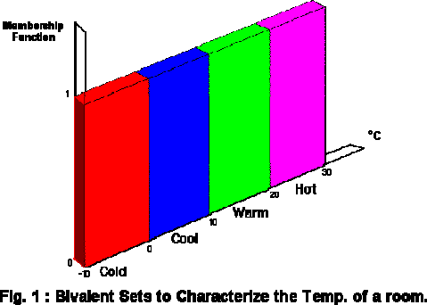

The most obvious limiting feature of bivalent sets that can be seen clearly from the diagram is that they are mutually exclusive - it is not possible to have membership of more than one set (opinion would widely vary as to whether 50 degrees Fahrenheit is 'cold' or 'cool' hence the expert knowledge we need to define our system is mathematically at odds with the humanistic world). Clearly, it is not accurate to define a transiton from a quantity such as 'warm' to 'hot' by the application of one degree Fahrenheit of heat. In the real world a smooth (unnoticeable) drift from warm to hot would occur. This natural phenomenon can be described more accurately by Fuzzy Set Theory. Fig.2 below shows how fuzzy sets quantifying the same information can describe this natural drift.

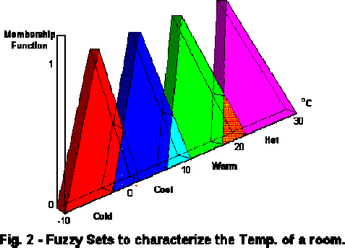

The whole concept can be illustrated with this example. Let's talk about people and "youthness". In this case the set S (the universe of discourse) is the set of people. A fuzzy subset YOUNG is also

defined, which answers the question "to what degree is person x young?" To each person in the universe of discourse, we have to assign a degree of membership in the fuzzy subset YOUNG. The easiest way to do this is with a membership function based on the person's age.

Young(x) = {1, if age(x) <= 20, (30-age(x))/10, if 20 < age(x) <= 30,

0, if age(x) > 30}

A graph of this looks like:

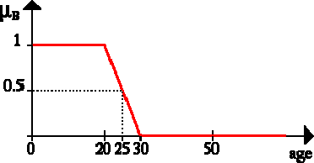

Given this definition, here are some example values:

|  |  |  |
| --- | --- | --- |
| **Person Age degree of youth** | **Person Age degree of youth** | **Person Age degree of youth** |
| Johan | 10 | 1.00 |
| Edwin | 21 | 0.90 |
| Parthiban | 25 | 0.50 |
| Arosha | 26 | 0.40 |
| Chin Wei | 28 | 0.20 |
| Rajkumar | 83 | 0.00 |

So given this definition, we'd say that the degree of truth of the statement "Parthiban is YOUNG" is 0.50.

**Note:** Membership functions almost never have as simple a shape as age(x). They will at least tend to be triangles pointing up, and they can be much more complex than that. Furthermore, membership functions so far is discussed as if they always are based on a single criterion, but this isn't always the case, although it is the most common case. One could, for example, want to have the membership function for YOUNG depend on both a person's age and their height (Arosha's short for his age). This is perfectly legitimate, and occasionally used in practice. It's referred to as a two-dimensional membership function. It's also possible to have even more criteria, or to have the membership function depend on elements from two completely different universes of discourse.

# Fuzzy Set Operations. Union:

The membership function of the Union of two fuzzy sets A and B with membership functions **µ** and **µ** respectively is defined as the maximum of the two individual membership functions. This is called the maximum criterion.

# µ A U B = max (µA, µB)

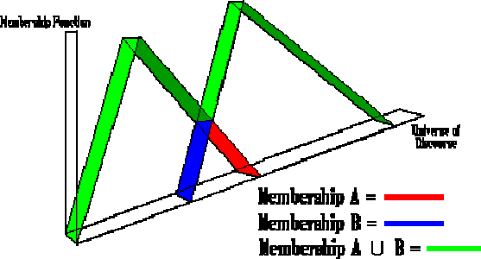

The Intersection operation in Fuzzy set theory is the equivalent of the **AND** operation in Boolean algebra.

# Complement

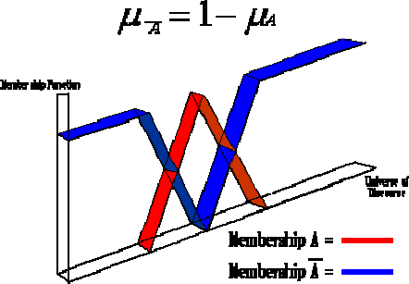The membership function of the Complement of a Fuzzy set A with membership function **µ** is defined as the negation of the specified membership function. This is caleed the ***negation*** criterion.

The Complement operation in Fuzzy set theory is the equivalent of the NOT operation in Boolean algebra.

The following rules which are common in classical set theory also apply to Fuzzy set theory.

# De Morgans law:

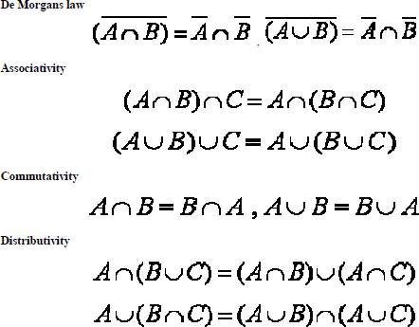

Let A1, A2, ….., An be fuzzy sets in U1, U2, …Un, respectively. The Cartesian product of A1, A2,

….., An is a fuzzy set in the space U1 x U2 x…x Un with the membership function as: μA1 x A2 x…x An (x1, x2,…, xn) = min [μA1 (x1), μA2 (x2), …. μAn (xn)]

So, the Cartesian product of A1, A2, ….., An are donated by A1 x A2 x….. x An.

# Cartesian product:

Example Let A = {(3, 0.5), (5, 1), (7, 0.6)} Let B = {(3, 1), (5, 0.6)} The product is all set of pairs

from A and B with the minimum associated memberships Ax B = {[(3, 3), min (0.5, 1)], [(5, 3),

min(1, 1)], [(7, 3), min(0.6, 1)], [(3, 5), min(0.5, 0.6)], [(5, 5), min(1, 0.6)], [(7, 5), min(0.6, 0.6)]} =

{[(3, 3), 0.5], [(5, 3), 1], [(7, 3), 0.6], [(3, 5), 0.5], [(5, 5), 0.6], [(7, 5), 0.6]}.

# Conclusion:

Thus we learnt implementation of Union, Intersection, Complement and Difference operations on fuzzy sets. Also created fuzzy relation by Cartesian product of any two fuzzy sets.